**GENN004 Spring 2020 Final Assessment**

**Research Project 2**

**Students Management System**

**Omar Mohamed Faheem Mostafa**

**Code: 1190477**

**E-mail: omarmohamedfaheem@gmail.com**

Below are the screenshots of my program (main menus and sub menus) and comments under the screenshot.

**MAIN MENU:**

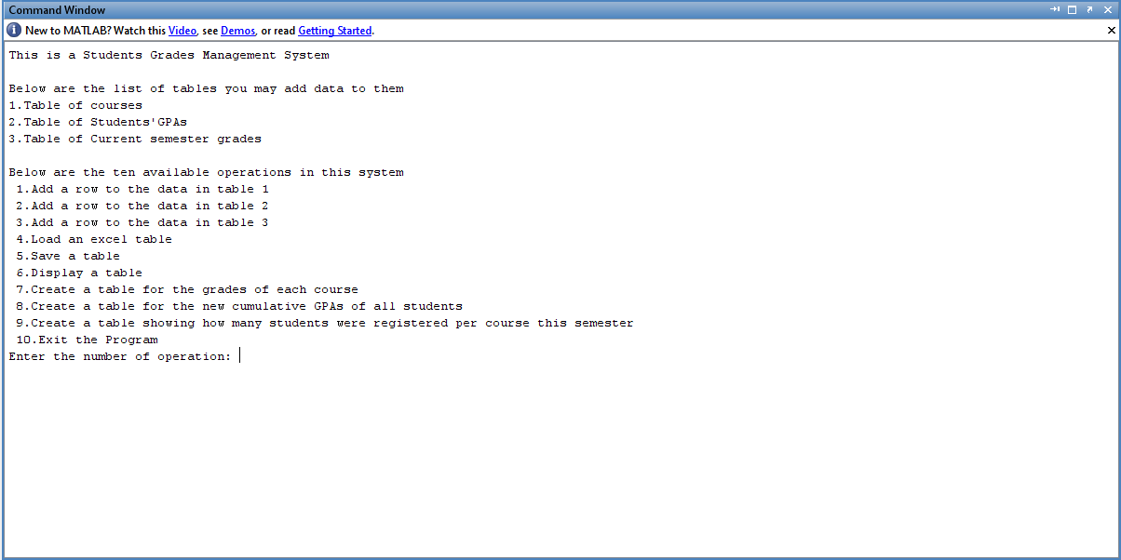

The main menu shows the list of operations in this grades management system and lists the tables with numbers to help the user when using operations 1, 2 or 3 to know which table the data is added to. Then operations 4, 5 and 6 contain a sub menu that the user go through to know which data he/she want to display, load or save. Finally operations 7, 8 and 9 computes tables using the data in table 1, table 2 and table 3 and the user have two options where he/she could display the table in the command window or to save the table as an excel file.

**SUB MENUS:**

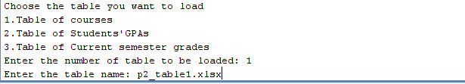**Step 4 (Load an excel table)**

**Step5 (Save a table)**



**Step6 (Display a table)**

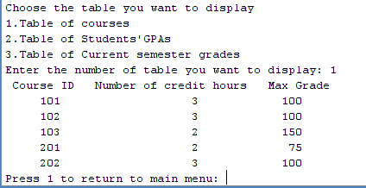

**How the NEW Cumulative GPA was calculated:**

The new cumulative GPA was calculated by using the data in table 1, table 2, table 3 and **table 7**. **Table 7** was created using the data in table 1, table 2 and table 3 and contained the GPA of each course in the current semester. The **GPA of each course** was calculated by adding the final exam grade and the coursework of each course that was in **table 3** and dividing the sum of coursework grade and final exam grade by the max grade of each course that was in **table 1**, then **multiplying the product of the sum and division by 4** to get the GPA of each course.

Now the new semester GPA of a student was calculated by **multiplying the GPA of every course by its number of credit hours then after multiplying every course by its number of credit hours for the student, the product of this multiplication was divided by the new number of completed credit hours, and then we have our new semester GPA so this new semester GPA was added to the old cumulative GPA of the student that is in table 2 and the product of the sum was divided by 2 to get the NEW Cumulative GPA.**

%in step 7 there is a student with an ID of 1455, who took the course of ID 201 with the max grade of course of 75 his/her GPA for this course was 5.066667 as sum of the coursework and the final exam grade was 95 which exceeded the max grade, so the GPA to be found was greater than 4.

%in step 8, I added the algorithm of step 7 (excluding the display and save options) to the beginning of step 8 to not force the user to load table 7 if the user wants to use step 8 directly because as mentioned above table 7 was used in step 8 to calculate the new cumulative GPA.

**Other Menu Items:**

**STEP 1**

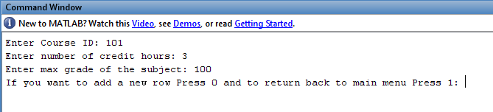

**STEP 2**

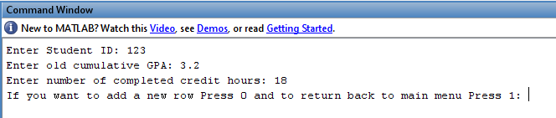

**STEP 3**

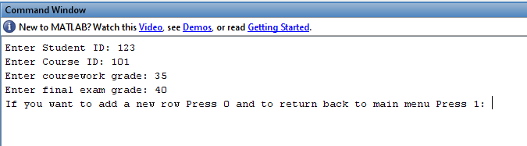

**STEP 7**

**Display:**

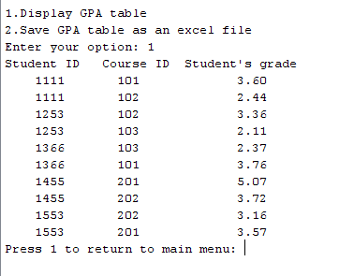

**Save:**



**STEP 8**

**Display:**

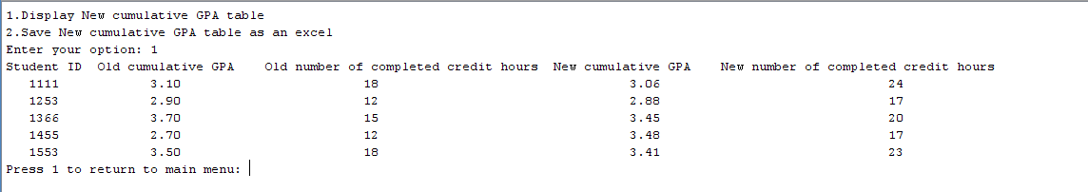

**Save:**



**STEP 9**

**Display:**

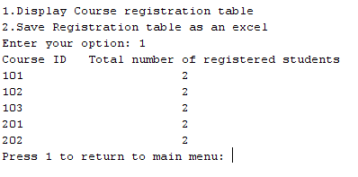

**Save:**

